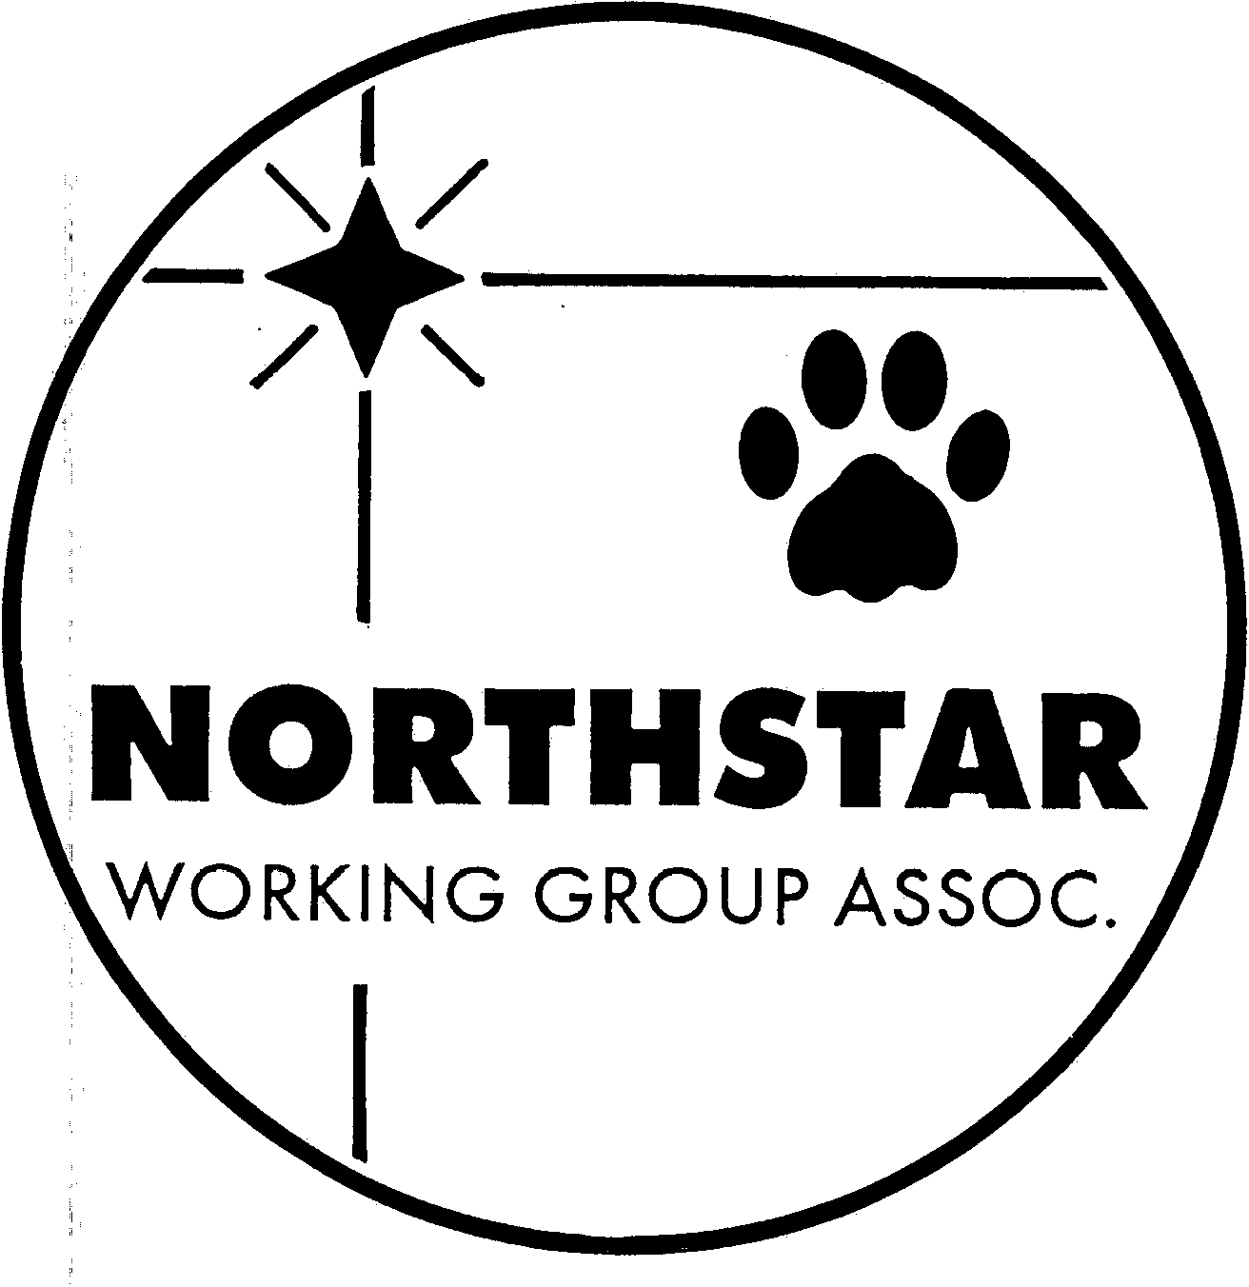

NORTHSTAR WORKING GROUP ASSOCIATION
MEMBERSHIP APPLICATION

Membership applications will not be accepted with incomplete information.
DUES FOR THE YEAR AND A LETTER OF RECOMMENDATION FROM ONE SPONSOR MUST accompany the application. Applicants under 18 years of age require co-signature of a parent or guardian.

Name:________________________________________________________________________ Date:______________________________

Address:______________________________________________________________________ City:_______________________________

State:_________ Zip:_____________ Telephone:________________________ Fax:_______________________________

E-mail:__________________________________________________ Occupation:__________________________________________________

Breed/Breeds Owned:________________________________________________________________________________________________________

Check all areas that apply:
_____Exhibitor (AKC events in the past 2 years): _____Conformation _____Obedience _____Agility _____Other: _________
_____Breeder: Indicate number of litters whelped within the past 2 years _____
_____Judge: _____Conformation _____Obedience _____Agility _____Other: ____________________________________________
_____Instructor: _____Conformation _____Obedience _____Agility _____Other: _______________________________________
_____Interested Dog Owner

Areas of interest or committees on which you would like to serve:
_____Educational Programs _____Performance Events _____Breed Referral
_____Match/Show Organization _____Community Service _____Publicity
_____Fundraising Activities _____Trophies and Awards _____Hospitality
_____Social Events _____Other:_______________________________________________________________________

Please list any special skills or talents (e.g., art, writing, photography, computing/desktop publishing, etc.) you have that may be of benefit to the club:______________________________________________________________________________________________________________
________________________________________________________________________________________________________________________________

I/We, the above named, hereby apply for membership in the Northstar Working Group Association (NWGA) and have enclosed dues for the year __________. I/We agree to abide by the Constitution and Bylaws of the NWGA and of the American Kennel Club.
Dues: Individual $15.00, Family $25.00, Junior $5.00, Associate (non-voting) $10.00

APPLICANT SIGNATURE(S):__________________________________________________________________________________________________

SPONSOR SIGNATURE:________________________________________ SPONSOR SIGNATURE:__________________________________________

A LETTER OF RECOMMENDATION from at least ONE sponsor MUST BE attached to this application and submitted with dues for the current year.

Send to: Diane Levin 22687 Forest Ridge Dr. Lakeville, MN 55044
___________________________________________________________________________________________________________________

Received:_____________________ Amount Paid:_________________ First Reading:________________
Second Reading:________________Third Reading/Vote:________________ Action: ________Accepted ________Denied Notification Date:__________________________

